CSD 310 – Module 2
Data Models Assignment
Jacob Richman
Due Date: August 24, 2026

Entity Relationship Diagram (ERD)

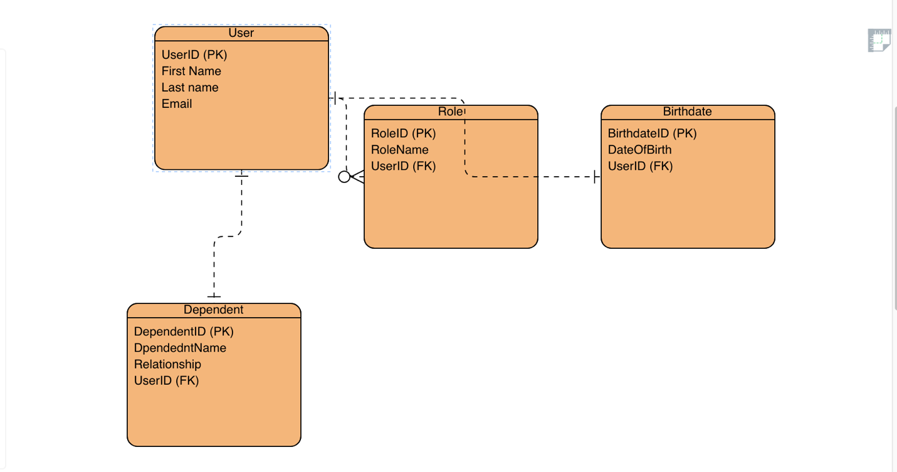
This ERD shows the relational structure for the USER table, including the related tables for Roles and Dependents. Each entity contains primary keys and foreign keys that define the relationships between the tables.

NoSQL Document Model
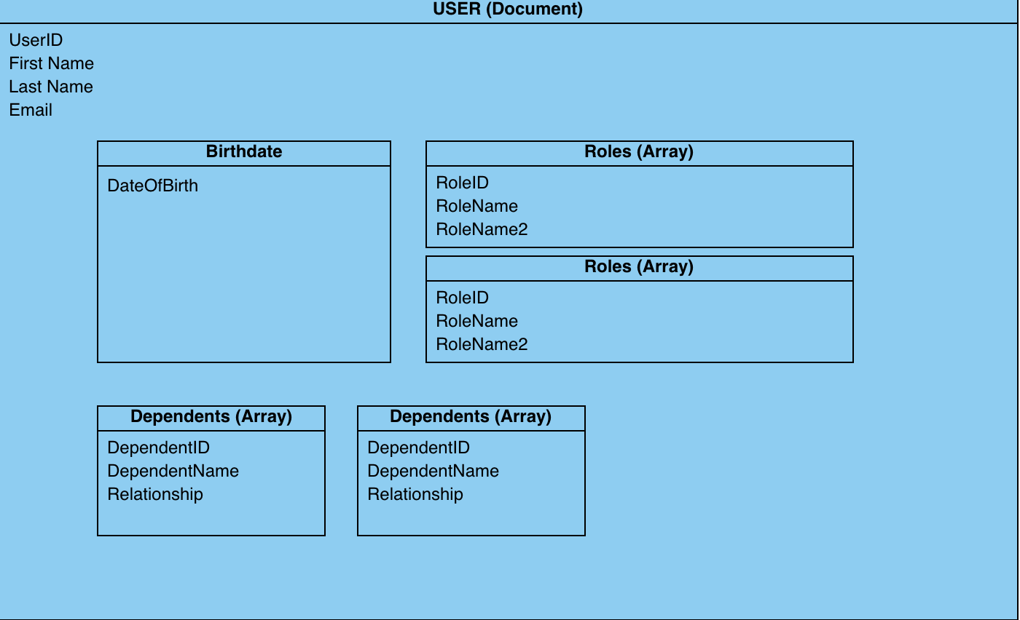
This NoSQL document model represents the USER document with nested objects and arrays.
- Birthdate is modeled as a nested object.
- Roles is modeled as an array of role objects.
- Dependents is modeled as an array of dependent objects.
This structure allows flexible storage without requiring foreign keys or table joins.

Business Rules
1. A user may have zero or many roles.
2. A user may have zero or many dependents.
3. A user has exactly one birthdate object.
4. Each role contains a RoleID and RoleName.
5. Each dependent contains a DependentID, DependentName, and Relationship.

Comparison: Relational vs NoSQL Models
The relational ERD organizes data into structured tables with primary keys and foreign keys, which enforce strict relationships and data integrity. In contrast, the NoSQL document model stores all related information inside a single USER document, including nested objects and arrays. This makes NoSQL more flexible and easier to scale horizontally, while relational databases provide stronger consistency and structured querying. Both models represent the same business rules, but they differ in how the data is stored and accessed.

Conclusion
This document includes the ERD, NoSQL model, business rules, and a comparison of relational and document-based data structures. All screenshots and diagrams were created using Visual Paradigm Online.

